**Front-End Brief**

**Project Overview**

This project delivers a multi-platform front-end system composed of a Web Dashboard (Admin/Manager interface) and a Mobile Application, both integrated with a unified backend API.

The solution is part of a larger system that manages materials, recipes, products, machines, orders, advertising, and telemetry data for automated chemical machines.

The goal is to provide a seamless, secure, and responsive interface for both administrative operations (via the dashboard) and user interaction with their assigned machines (via the mobile app).

**Objectives**

* Provide ABAC (Attribute-Based Access Control) to manage recipes, products, machines, and advertising content.
* Maintain real-time visibility into machine states, orders, and executions via dashboards and live updates.
* Support efficient CRUD operations for recipes, groups, materials, and related entities with strong data validation and auditability.
* Deliver a consistent UX/UI across desktop and mobile with localization (English/Arabic) and accessibility compliance.
* Dashboard and Application

**Key Features**

* **Dashboard**

|  |  |  |
| --- | --- | --- |
| Module | Description | Key Features |
| Authentication | Secure login and ABAC enforcement. | * login * reset password * token-based sessions * secure token storage |
| Access Control | Manage users, their information, roles, and permissions. | * User management * Roles management * Permissions Management |
| Brands Management | Manage brands and brand managers to give him access to control their groups and recipes. | * Brands * Brand managers |
| Base Chemical Management | Manage materials and group them logically. | * Material management * Groups management * Filtering and Pagination |
| Store Management | Manage group and machine orders as well as contacting users and assigning delivery to orders, in addition to managing shipping. | * Order management * Shipping management * Machine order * Contract management |
| Produce Management | Categorize products, recipes with details, and neutralizers search and filters. | * Categories management * Products management * Recipes management * Neutralizers * Recipe details management * Phases and steps management * Searching, Filtering & Pagination |
| Machines & Telemetry | Manage machine metadata and monitor health. | * Machines management * Units management * View container levels * Monitor Heartbeats |
| Orders & Execution | Visualize product requests, orders, and logs additionally to feedbacks | * Execution Order * Real-time progress monitoring * Real-time step timeline monitoring |
| Advertising Management | Manage offers, promotions, and coupons  Additionally, manage promotion rules and actions that apply to the cart. | * Promotion management * Promotion rules and actions management * Coupons management |

* **Mobile**

|  |  |  |
| --- | --- | --- |
| Module | Description | Key Features |
| Authentication | Secure User login via email/password.  Sign up as well as verify the user via email OTP | * Login * Signup * Verification via OTP * Reset password * Token-based sessions * Secure token storage |
| Profile Management | View and edit user details.  Edit the theme of the application | * User details management * Theme management * Change language |
| Home View | Beautiful screen and showing machine and current process, either making product execution or flushing additionally banners and offers. | * Home view and simple icons for moving to other flows * Call to action button * View banners and offers * Current execution process |
| Machines & Telemetry | Manage machine metadata and monitor health as well as the units and container groups level. | * Machines management * Permit to use * View container levels * Monitor Heartbeats |
| Store Module | Add groups to the cart and request machines or units, as well as apply coupons to the cart, also check out cart  In addition, track the order and show the order history. | * Cart management * Order management * Order status update * Shipping management * Machine order |
| Product Module | Show products and ability to make the product based on recipe also show estimate time to complete. | * Category filtration * Brand filtration * View products * Show recipe estimate time and steps count * Searching, Filtering & Pagination |
| Orders & Execution Module | Visualize product requests, orders, and logs.  After complete produce product, the user should make feedback and rating | * Execution Order * Real-time progress monitoring * Real-time step timeline monitoring * Feedback * Rating |
| Notification Module | Gather and display alerts, updates, and messages in one consolidated place | * Real-time notification * Show important notification on the mobile notification center |

**Technical Requirement**

* **Dashboard**
  + **Role:** Admins, Managers, and Operators
  + **Purpose:** Manage all operational data (recipes, materials, products, machines, …etc)
  + **Language:** Typescript
  + **Security:** Token must be in a secure place + security test must be applied
  + **Technology Target:** Responsive SPA (Nextjs App)
  + **UI Components:** Shadcn-UI/Chakra-UI
* **Mobile Application**
  + **Role:** User
  + **Purpose:** Operate machines, request product manufacturing, monitor progress, receive offers, and manage personal accounts
  + **Language:** Dart
  + **Technology Target:** Flatter Framework
  + **State Management:** Cubit/Bloc
  + **Router:** AutoRoute/GoRouter …etc
  + **Recommended Package:** skeletonizer + Dartz + Dio + Equalizer + rexdart

**Non-Functional Front-End Goals**

|  |  |
| --- | --- |
| **Category** | **Goal** |
| Performance | First render under 3s on standard broadband; 95% of dashboard list views load under 300ms. |
| Scalability | Support thousands of concurrent sessions; client caching to reduce API load. |
| Maintainability | Modular UI components, isolated business logic (BLoC/Clean Architecture). |
| Extensibility | New modules (e.g., analytics or reporting) can be plugged in easily. |
| Security | Strict ABAC, token-based access, client-side encryption for sensitive local storage. |
| Monitoring | Integrated logging for client errors and telemetry tracking |

**Timeline And Deliverables**

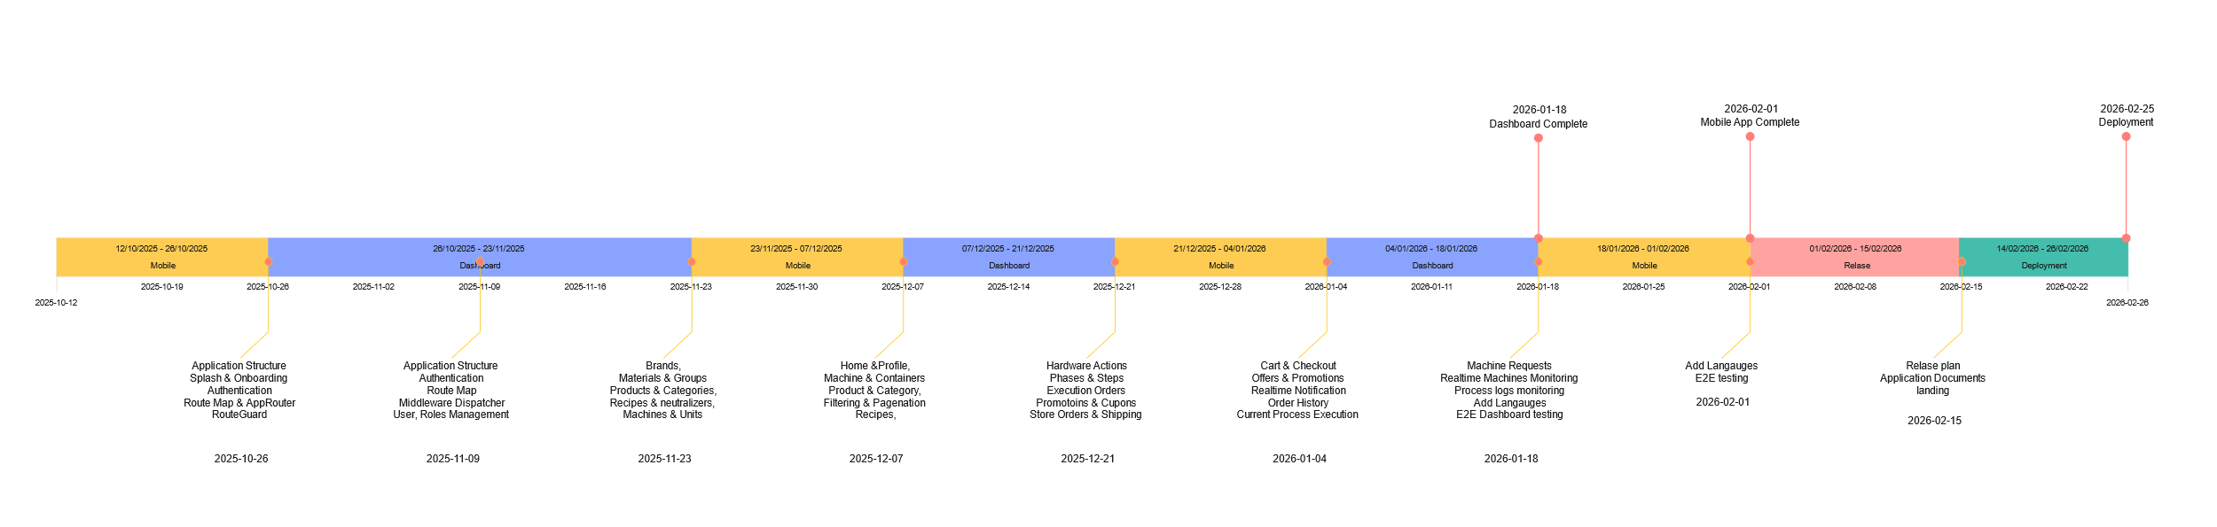

**Stakeholders And Roles**

|  |  |  |
| --- | --- | --- |
| Name | Mohammed Kuthari | Awsan Al-Ward |
| Roles | Software Engineer  Technical Leader | Scrum Master |